**Does the Selective Erasure of Protected Areas**

**Raise Deforestation in the Brazilian Amazon ?**

Derya Keles* a, Alexander Pfaff b and Michael Masciac

*April 14, 2020*

Abstract (183 words)

Protected areas (PAs) have long been the leading conservation tool for deterring deforestation. However, there is resistance to PAs from land users who lose profit. That can lead to remote sites for PAs and to illegal deforestation within PAs, both of which reduce the PAs’ forest contributions. After a PA is established, land users who lose from PAs may endeavor to reduce that protection: PA downgrading, downsizing and degazettement (collectively ‘PADDD’) are reductions in status (downgrading) or in size (downsizing or degazettement, i.e., the partial or full erasure of the PA). For the entire Brazilian Amazon, we estimate the impact of 2009-2012 PA erasures on 2010-2015 post-erasure loss of forest cover. We use matching in light of the relevant results for PADDD risks: for the Brazilian Amazon, PA erasures occur more near economic pressure − where deforestation is more likely (Tesfaw et al., 2018; Keles et al., 2019). Conceptually, erasures cause deforestation if the PAs faced and at least somewhat blocked pressures. Empirically, we find exactly that: since most forests selected for PA erasures faced pressure, these PA size reductions raised forest loss.

*Keywords: protected areas, PADDD, conservation, Brazil, Amazon, political economy, impact evaluation*

* Lead author (not alphabetical)

a Université de Lorraine, Université de Strasbourg, AgroParisTech, CNRS, INRAE, Bureau d’Economie Théorique et Appliqué (BETA), Nancy, France (derya.keles@inrae.fr)

b Duke University, Sanford School of Public Policy, Durham, NC USA (alex.pfaff@duke.edu)

c Moore Center for Science, Conservation International, Arlington, Virginia, USA (mmascia@conservation.org)

Acknowledgments The BETA contributes to the LabEX ARBRE ANR-11-LABX-0002-01. We thank Philippe Delacote and Gwenole Le Velly for advice, Siyu Qin for early data guidance. We also want to thank attendees at the 26th Ulvön Conference on Environmental Economic organised by the CERE and Umeå University, and at seminars held in Montpellier (CEEM) and Clermont-Ferrand (CERDI) for comments on these analyses.

# **1. Introduction**

PAs are the most widely used tool for conserving forests, globally, while Brazil hosts globally critical forests, including in its Amazon region. Brazil is the 7th-largest GhG-emissions contributor, due to the conversion of Brazilian Amazon rainforest to pasture and agricultural lands (Azevedo-Ramos and Moutinho, 2018), and in the 2016 Paris agreements committed to decrease its GhG emissions by 43% below 2005 levels by 2030, mainly through further reductions in deforestation (Gallo and Albrecht, 2019). Further, Brazil’s Amazon region contains half of the world’s tropical rainforest and is a biodiversity hotspot (Campos-Silva et al., 2015; Gallo and Albrecht, 2019). For these reasons, PAs have been a leading tool in Brazil’s Amazon since the 1980s (Campos-Silva et al., 2015; Nogueira et al., 2018; Veríssimo et al., 2011). The national PA system expanded with influences from several international commitments, including in the World Park Congress in Bali, the 1992 United Nations conference on environment and development, and the Conventions on Biological Diversity in both 2004 and 2010 (Visconti et al., 2019). This network now covers over 30% of Brazil’s territory (UNEP-WCMC, 2020) and over 50% of the Brazilian Amazon (Campos-Silva et al., 2015), and has been shown to reduce deforestation, on average (Pfaff et al., 2015).

Yet PAs’ impacts on deforestation are constrained by the PAs’ locations, which vary considerably. Outside of high-pressure areas such as the ‘Arc of Deforestation’, fewer land uses are profitable and, thus, forest often remains even without protection (Herrera et al., 2019; Pfaff et al., 2015). Put another way, PAs far from economic pressure often do not reduce deforestation significantly. PA impacts also can be limited by illegal deforestation inside PAs, due to imperfect enforcement (Amin et al., 2019; Carranza et al., 2014; Jusys, 2018, 2016; Kere et al., 2017; Nolte et al., 2013).

After conservation policies helped to decreased Amazon deforestation rates by more than 70%, from 2004 to 2011 (Azevedo-Ramos and Moutinho, 2018), deforestation doubled from 2012 to 2019 (INPE, 2019). The initial fall in deforestation rates followed from increased enforcement and an increase in the area protected within the Amazon. In turn, the recent rise appears to follow from reduced enforcement, even to the point of a ‘license to deforest’, including in protected areas − in which we include indigenous land (Carvalho et al., 2019; Ferrante and Fearnside, 2019). Protection can also be challenged legally, by: permitting additional activities inside PAs; partially erasing a PA, decreasing its size; or fully erasing a PA, i.e., eliminating it by reducing size to zero (Mascia and Pailler, 2011). Those events – i.e., PA downgrading, downsizing, and degazettement (collectively, ‘PADDD’) – often accommodate infrastructure, agriculture, resource extraction, and rural settlements (Bernard et al., 2014; Cook et al., 2017; Ferreira et al., 2014; Kroner et al., 2019; Mascia et al., 2014; Naughton-Treves and Holland, 2019; Pack et al., 2016; Symes et al., 2016).

Some PADDD events occurred within the Brazilian Amazon between 1970 and 2000. The pace of PADDD then increased, however − especially during 2008-2015, when 44,000 square km of PAs were lost to reductions in PAs’ sizes, i.e., the partial or complete erasure of PAs (Campos-Silva et al., 2015; Kroner et al., 2019). This PADDD acceleration reflected a lack of Brazilian political and technical support for conservation objectives, including as expressed through a scarcity of funds and human resources allocated for management of PAs (Bernard et al., 2014; Campos-Silva et al., 2015; Ferreira et al., 2014; Rochedo et al., 2018; Veríssimo et al., 2011; Visconti et al., 2019).

Given that temporal shift, to inform future policies and improve assessments of PADDD impacts we would like to understand better why PADDD affected particular PAs within this landscape. Conceptually, development-oriented agents will propose PADDD, and bargain to enact PADDD, if they have economic gains from deforestation where PAs stand. Conservation-oriented agents, in contrast, bargain against PADDD if they see conservation gains from blocking human pressures (Keles et al., 2019; Tesfaw et al., 2018). Many outcomes are possible from bargaining over PAs. Empirically, then, it has been found that the accessibility of a PA to market, the PA’s size, and the rates of previous internal deforestation inside the PA’s boundaries – driven by a range of factors (Naughton-Treves and Holland, 2019; Visconti et al., 2019) – all seem to increase the likelihood of a PA experiencing a size reduction (Pack et al., 2016; Tesfaw et al., 2018; Keles et al., 2019).

Those results on risk – Keles et al. (2019) for the entire Brazilian Amazon − make it hard to predict whether selective PA erasures will raise deforestation. If the reason size was reduced was internal deforestation − e.g., all profitable deforestation occurred already – then reducing a PA’s size may have no impact. That is relevant, as prior internal deforestation increased risks of size reductions (Tesfaw et al., 2018; Keles et al., 2019). Also, if the context for a PA’s size reduction was a remote location with low deforestation pressure, again PA size reductions might not affect deforestation, as even without a PA there may be no profits from deforestation in such a location. Yet the result that size reductions are more common near markets suggests that reduced PAs faced pressure. As they may have blocked pressure, at least somewhat, size reductions could raise deforestation.

The few empirical results on forest impacts from PADDD are mixed. Golden Kroner et al. (2016) say that 150 years of legal changes in the Yosemite National Parks in the United-States increased habitat fragmentation due to infrastructure construction to accommodate rural settlement and resource extraction. It has also been showed that higher deforestation rates and greenhouse gas emissions followed from PADDD enactment in Peru and Peninsular Malaysia (Forrest et al., 2015). Yet for one Brazilian Amazon state, Rondônia, Tesfaw et al. (2018) found no average short-term forest impact, consistent with size reductions being more likely to be proposed and enacted in higher-pressure locations, where significant internal deforestation was already occurring in PAs. Again, that could result from bargaining, in which ‘failing’ PAs are those allowed to be reduced. For all the Brazilian Amazon, Pack et al. (2016) use difference-in-differences to separate shifts in 2002-2011 deforestation due to PADDD from shifts due to fixed other factors (observed or not). They find no downsizing impact: downsized parts had the same deforestation as still-protected.

Yet long-run results can differ. Infrastructure does not always immediately raise deforestation – especially in remote sites (Pfaff et al., 2018; Tesfaw et al., 2018) – but over time activities build, e.g., if construction starts as PADDD occurs. Even for fixed infrastructure, a change in the views of government can change expectations and investments (per recent political shifts, see Carvalho et al., 2019; Casarões and Flemes, 2019; Escobar, 2019; Fearnside, 2016; Ferrante and Fearnside, 2019). As noted above, while after 2004 Amazonian deforestation fell for some years, it has been rising since 2012. Reconsidering deforestation impacts of PA size reductions in this latter context, then, seems well worthwhile − at the very least to allow for this shift in socioeconomic context.

To allow for the influences of such shifts over time on the deforestation impacts of erasing PAs, while also considering important differences across space in the context of the PA size reductions, we evaluate the impacts of enacted 2009-12 PA size reductions (downsizing/degazettement) on 2010-2015 post-reduction forest loss. Like Pack et al. (2016), we study all of the Brazilian Amazon. However, not only do we extend their results with more recent events, and recent deforestation, critically we also distinguish subsets of PAs across which the impacts of reductions should differ.

Our contributions are the following. First, we lay out a simple conceptual model to suggest where reducing PA size is more likely to raise deforestation. Second, we focus not on the average impact, for an enormous and incredibly diverse region, but instead impacts by context. To reduce biases, for each context we employ matching at pixel level for observed characteristics of forested lands that may influence both the likelihood of deforestations and the likelihood of PA size reductions. We use this same method to estimate 2001-208 pre-reduction forest impacts of PAs − a critical summary of PAs’ varied contexts − and separate contexts by ‘expected deforestation pressure’. We proxy for differences in economic pressure using large regions, states, and road distances.

To start with an average impact, we find that to-be-reduced PAs, i.e., those selected for erasures in 2009-2012, increased 2001-2008 deforestation rates relative to no protection. That shows a lack of effective protection, different from constant-sized PAs (i.e., the majority). Consistent with our theory for partial enforcement, those PA size reductions then also increased deforestation, with higher post-erasure 2010-2015 forest-cover losses in reduced areas than constant-sized PAs. On average, then: PAs suffered internal deforestation, got reduced, then forest loss went further.

However, even among the reduced PAs that faced clearing pressure, outcomes were not equal − in line with different prior PA impacts upon forests. To-be-reduced PAs in Pará neither reduced (as did the majority of constant PAs) nor raised (as did the majority of reduced PAs) 2001-2008 deforestation. In turn, the PA size reductions in Pará did not increase deforestation in 2010-2015. While we believe that Pará indicates a particular political economy in one context with pressure, a lack of pressure is another reason size reductions have no impact. Consistent with that theory, we find a consistent story for: high road distances; the entire state of Amazonas; and the whole non-Arc region. We show no prior impacts from those PAs, then no impacts from their erasures.

The rest of the manuscript is organized as follows. Within Section 2, we offer relevant background and a simple framework for considering where PA erasures are more likely to increase forest loss. Section 3 presents our empirical strategy, Section 4 our estimates for impacts of PAs then impacts of PA erasures − including for subsets based on prior impacts − and Section 5 provides discussion.

# **2. Historical Background & Conceptual Model**

## 2.1 Deforestation & Forest Protection in the Brazilian Amazon

Brazilian Amazon deforestation rose in the 1960s, along with the will of the military dictatorship to develop the economy of the region (Hargrave and Kis-Katos, 2013; Souza-Rodrigues, 2019). To support settlement and economic activities, roads were built and incentives given, all interacting with insecure land tenure and allowing both land grabbing and illegal logging (Araujo et al., 2009). When the economy stabilized during the 1990s, deforestation was also driven by rising demand for exports, as the country became a major supplier of beef and soybeans (Arima et al., 2014).

Following international interactions including the 1982 World Parks Congress and 1992 United Nations conference on environment and development, as well as public concerns (Naughton-Treves et al., 2005; Veríssimo et al., 2011), IBAMA was created to enforce the environmental laws (Arima et al., 2014). At that time, PAs started to be grow (Figure 1), largely as a means to conserve biodiversity, and the required share of forest cover (‘legal reserve’) on private land was increased from 50% to 80% (Arima et al., 2014; Souza-Rodrigues, 2019). However, relevant enforcement remained poor (Naughton-Treves et al., 2005; Veríssimo et al., 2011) and the deforestation rate increased until a peak in 2004, when 26,800 squared kilometres of land were cleared (Figure 2).

Figure 1 Protected Area designations and size reductions

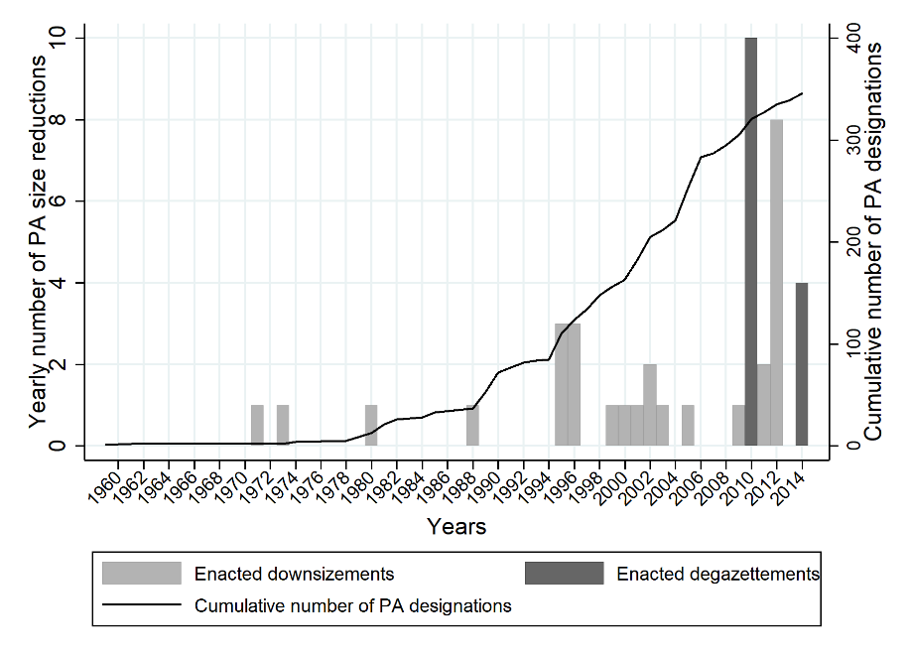

Source: author’s calculation (IUCN and UNEP-WCMC, 2017; WWF,2017a)

Figure 2 Deforestation in the Brazilian Amazon

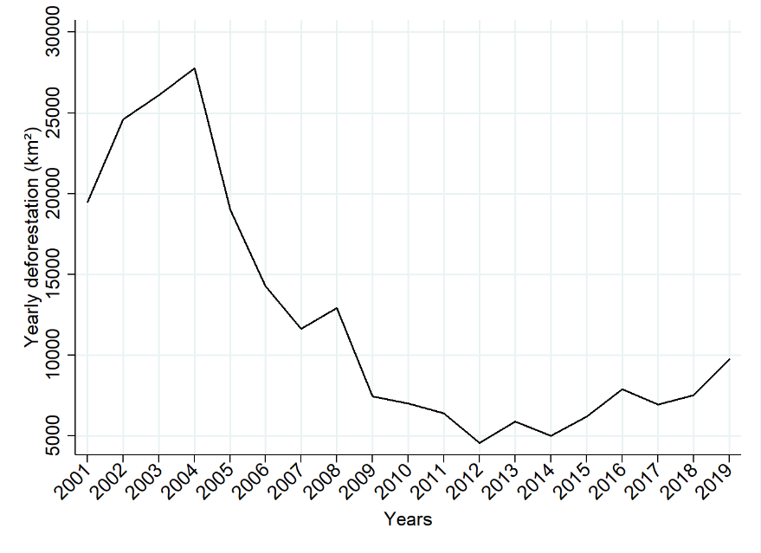

Source: author’s calculation from (INPE, 2019)

Yet then, given policy responses as well as the 2008 economic crisis (Arima et al., 2014; Assunção et al., 2015; Hargrave and Kis-Katos, 2013; Soares-Filho et al., 2014; Veríssimo et al., 2011), deforestation fell sharply from 2004 to 2011 when it was 5,800 squared kilometers. A key policy initiative in 2002 was ‘The Amazon PA Program’ (ARPA) to extend the PA network and improve PA management (Figure 1). To enforce environmental laws, the Real-Time System for Detection of Deforestation (DETER), using satellites, was implemented by the National Institute for Space Research (INPE) within the 1st phase of the Action Plan to Prevent and Control Deforestation in the Amazon (PPCDAm-I) (Arima et al., 2014; Souza-Rodrigues, 2019; Veríssimo et al., 2011). Next, PPCDAm-II (2009-2011) added measures such as: more frequent inspections and applications of sanctions by IBAMA; a list of priority municipalities subject to stricter enforcement (Arima et al., 2014; Assunção et al., 2015; Souza-Rodrigues, 2019); new punishment instruments (embargoes, seizures); and conditioning of rural credit on environmental compliance (Gibbs et al., 2016).

From 2012 on, however, the drop in deforestation had ceased. Since 2014, in fact, deforestation again started to rise as a result of political changes weakening environmental law (Arima et al., 2014; Campos-Silva et al., 2015; Fearnside, 2016; Gallo and Albrecht, 2019; Rochedo et al., 2018; Soares-Filho et al., 2014). For example, a 2012 revision of the Forest Code provided amnesties to landowners whose legal forest reserves had been cleared before 2008 (Soares-Filho et al., 2014). In addition, environmental requirements were lowered, infrastructure projects (dams, highways) were facilitated, and along with this effort to foster economic growth, the PA network has been undermined (Arima et al., 2014; Fearnside, 2016; Naughton-Treves and Holland, 2019; Rochedo et al., 2018; Soares-Filho et al., 2014). As early as 1970, PAs were reduced. Yet the phenomenon has accelerated recently, mostly in order to accommodate infrastructure projects, settlements and expansions of agriculture (Kroner et al., 2019; Mascia and Pailler, 2011; Pack et al., 2016). Specifically, 40 PA size reductions were enacted in recent decades in the Brazilian Amazon, with an area of 157,377 squared kilometres, and 25 erasures concentrated between 2009 and 2012, covering 42,113 squared kilometres (Figure 1). The recent election of President Jair Bolsonaro has also sent very clear signals to prioritize economic growth over conservation, thus incentives to clear the forest have been increased. Forest fires, which have doubled compared to last year, are in part a consequence of deforestation activities (Casarões and Flemes, 2019; Escobar, 2019).

## 2.2 Impacts of Protection & PA Size Reductions

### *2.2.1 Deforestation Baselines & PA Impacts By Location*

Frontier deforestation is often thought to resemble von Thünen’s model (Angelsen, 2010, 2007; Sims, 2014). To illustrate, consider a risk-neutral agent facing a choice to clear forest on parcel *i*, which is not protected, to earn agricultural rents *Yi* . Rents are *p*, the price of the product in the nearest market, times the parcel’s output yield − which is a function of land quality *f*(*Qi*). From those revenues, one must subtract the transport costs to get one’s output to the nearest market. Assuming per-unit *Ti* is linear, costs *Ti* *di* rise with the distance of the parcel to the nearest market. Thus, *Yi* falls with *di* and, in turn, the forest clearing falls with *di*, ending at the ${\overline{d}}_{i}$ for which *Yi* = 0.

$Y_{i}=pf\left(Q_{i}\right)- T_{i} d_{i}$ → ${\overline{d}}_{i}=\frac{pf\left(Q_{i}\right)}{T_{i} }$ (1)

Within any PA, agents face fines for deforestation *F*. Those reduce the rents from agriculture, so *YiP* < given a chance of being caught (*πiP* > 0). Yet transport costs hinder enforcement. For the Brazilian Amazon, illegal deforestation in PAs is higher far from urban centers (Keles et al. 2019). Thus we assume that enforcement near cities, where agencies are located, is sufficient to prevent illegal deforestation nearer to those agencies, yet then it falls in effectiveness with city distance. We would then expect that PAs would not lower deforestation either: beyond ${\overline{d}}_{i}$, where already profit is negative without a PA; or when enforcement was effectively zero, due to transport costs. PAs at low to intermediate distances, then, may discourage baseline deforestation (Figure 3):

$Y_{i}^{P}=pf\left(Q_{i}^{P}\right)- T_{i}^{P}\left(d_{i}^{P}\right)- π_{i}^{P}F$ → ${\overline{d}}_{i}^{P}= \frac{p f\left(Q_{i}^{P}\right)- π_{i}^{P}F }{T_{i}^{P}}$ (2)

Proposition 1: PAs lowers forest clearing *(i.e., deforestation would occur without any PA but not given a PA and enforcement)* near to urban centers, as enforcement is strong; and a bit further out from the cities, where enforcement is weaker yet profit is lower.

### *2.2.2 Locations & Impacts of PA Size Reductions*

Development agents may bargain against PAs when profits from clearing forest would be high (Keles et al., 2019; Tesfaw et al., 2018). When a PA (or part of a PA) is erased, i.e., its size is reduced, then the fines disappear for clearing those forests, making *YiR = Yi*. Of course, this will raise deforestation only in the very same range of distances in which the PA was saving forest: close enough to cities that deforestation occur without PAs (below ${\overline{d}}_{i}$); and also close enough that enforcement, which falls with city distance, generates expected fines above falling rents. Those are the conditions (see Figure 3) under which reducing a PA should raise deforestation.

Proposition 2:Reducing PAs’ sizes raises forest clearing if PAs have impact (see Proposition 1).

*Figure 3 Locations & Impacts of PA Designations and Size Reductions*

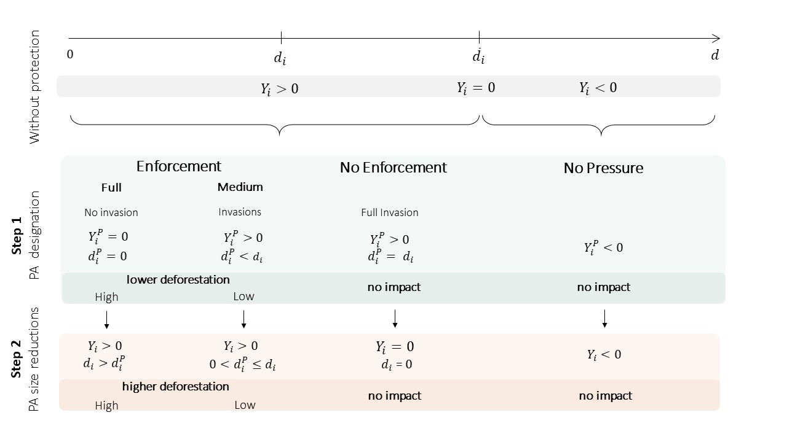

# **3. Empirical Approach**

## 3.1 Impact Estimation: matching both before & after erasures

We estimate deforestation impacts of PA size reductions. As is summarized just above (Figure 3), we do not expect impact above a threshold distance at which agriculture is not profitable. Below that threshold, PA impacts depend on enforcement. Not knowing the distance ranges in practice, we simply estimate PAs’ forest mpacts before size reduction. Only for PAs those that had lowered deforestation before a size reduction do we predict a rise in deforestation after that reduction. Thus, we estimate impact of PAs before size reduction (step 1) and of PA size reduction (step 2).

To know whether a PA lowered deforestation before reduction, we need a difference between the observed deforestation with protection and an estimate of the counterfactual deforestation that would have occurred had the PA never been created (Ferraro and Hanauer, 2014; Velly and Dutilly, 2016). Thus, we need information on unprotected forest. To learn whether size reduction raises deforestation, we need a difference between the observed deforestation after reduction and an estimate of the counterfactual deforestation that would have occurred had the PA been retained. Thus, we need the data on deforestation for appropriately selected protected forests.

For the required counterfactuals, we could use observed outcomes for treated parcels at times without treatment, e.g., before a PA was created. Yet deforestation varies over time independent of PAs, due to external shocks (e.g., a fall in agricultural prices (Assunção et al., 2015)). We could instead use average outcomes for untreated parcels to compare with averages for treated ones. Yet baseline deforestation would have to be the same for those groups to get a valid comparison of averages (Ferraro and Hanauer, 2014; Velly and Dutilly, 2016). In contrast to that requirement, within the Brazilian Amazon PAs have tended to be located farther from pressure than average unprotected forests (Pfaff et al. 2015). Also, the protected forests that have lost their PA status tend to be in relatively accessible places (Keles et al., 2019; Pack et al., 2016; Tesfaw et al., 2018).

Thus, we will be using matching approaches in order to find comparisons groups that are similar, since for both protection and PA size reduction, the treated and untreated are not similar. For each treatment – protection before size reduction and the reduction of protection – we will find the untreated forest parcels that are most observably similar to whatever parcels were treated. To estimate impacts of protection before reduction, we will search for the unprotected forests most similar to each protected parcel. To estimate the impacts of PA size reduction, though, we will search for the still-protected forest parcels most similar to those parcels that lost protection.

## 3.2 Data

### *3.2.1 Units of Observation*

We randomly drew 1,028,230 points from across the entire Brazilian Legal Amazon. To address the possibility of spatial autocorrelation, we enforced on the randomized draw a 1km minimum distance between observations (Avelino et al., 2016; Pfaff et al., 2009; Velly and Dutilly, 2016). In addition, we drop some observations because of the possibility of local PA ‘leakage’, i.e., that PAs might affect the land uses nearby. We exclude from the controls a 20km buffer zone around each PA (Abman, 2018; Joppa and Pfaff, 2011; Jusys, 2018; Nolte et al., 2013; Pfaff et al., 2015).

### *3.2.2 Variables*

We use forest-loss data at a 30x30m resolution from the new version of the Global Forest Change (Hansen et al., 2013). The data indicate the tree-cover density (10% to 75%) in 2000, for trees of more than 5 meters in height, and whether a pixel has been cleared each year from 2000 to 2015. We call ‘forest’ when tree-cover density is at least 30% at the start of a period[1].It is important to note that Global Forest Change data do not indicate a difference between natural and secondary planted forests (Sexton et al., 2016; Tropek et al., 2014). Also, Hansen et al. (2013) do not use the same methodology for tree-cover gains, making it impossible to compute net forest-cover loss.

Our deforestation outcome is a binary variable, indicating whether the forest cover has been lost: between 2001 and 2008, for pre-reduction PA impacts; and between 2010 and 2015, for impacts of reductions. For the former, we use locations forested in 2001. Thus, forest cover is considered to be lost whenever it falls to zero between 2002 and 2008. For the latter, that rule applies for post-reduction years between 2010 and 2015 (PA size reductions are between 2009 and 2012): forest cover is seen as lost if, post-reduction, the forest indicator falls to zero during 2011-2015.

We use protection data from the World Database on Protected Areas (WDPA) (IUCN and UNEP-WCMC, 2016), a spatially explicit database that describes PAs’ locations and frontiers. To avoid misinterpretation, we only use PAs that could be recorded in the PADDD data as reduced in size, i.e., all of the ‘units of conservation’ included within the National System of Protected Areas (Sistema Nacional de Unidades Conservação - SNUC). Thus, we have dropped both Indigenous Lands and Quilombola Territories. The conservation units are all classified according to the extent of the activities permitted inside. When a location appears in multiple PAs, we assigned it to the strictest classification among those PAs. Within our sample, we find 59,800 protected locations before 2000, while 458,394 locations were never protected. When estimating the 2001-2008 impacts of protection, the treated group of observations is all the locations inside PAs established before 2000, while the pool of potential controls is all of the locations never protected by 2008.

For PADDD, and more specifically all PA size reductions, we use PADDDtracker.org Data Release Version 1.1 (Conservation International and World Wildlife Fund, 2019), i.e., a spatially explicit database with descriptions of PA size reductions, their locations, and their boundaries. To study the PA size reductions, for the locations that were protected by 2008 we distinguish those PAs that were reduced in size between 2009 and 2012 from the PAs that remained protected through 2015 (i.e., the constant-sized PAs). We find 5,614 of the former parcels and 94,700 of the latter.

PA designations and reductions may be explained by bargaining given the agricultural profits that could be earned from using cleared forest land. That opportunity cost of conservation is affected by biophysical and socioeconomic characteristics of lands that influence agricultural suitability. We include slope and elevation from the Shuttle Radar Topography Mission (SRTM) (Jarvis et al., 2008) and we also obtain 1995-2015 rainfall levels in millimetres per year from the version 2.0 of Climate Hazard Group InfraRed Precipitation with Station Data (CHIRPS) (Funk et al., 2015). We use in addition an indicator of soil quality from the Global Agro-Ecological Zone (FAO and IIASA, 2019), which equals one if the land is suitable for high-input rainfed farming but zero otherwise. Agricultural profits also depend on market access. We use the road network in 1996, from the Center for International Earth Science Information Network (CIESIN) (2015), and in 2006 from the Brazilian Departamento Nacional de Infraestrutura de Transportes (DNIT, 2017). In addition, we use the network of navigable rivers, from the Environmental Systems Research Institute (ESRI, 2013) as well as the major cities from the Environmental Systems Research Institute (ESRI, 2013).

The size of a PA and its IUCN category, from the WDPA (IUCN and UNEP-WCMC, 2017), influence enforcement costs. We also use the number of endemic species in 2006 from a WWF WildFinder database on species distributions (WWF, 2006; Olson et al., 2001) to proxy environmental values.

## 3.3 Methods

### *3.3.1 Nearest-neighbour matching*

As noted, forest-cover loss for treated pixels is compared with losses for similar untreated pixels. If matching for similarity on key observable covariates eliminates all of the relevant differences, then the latter outcomes would differ from the former outcomes solely due to treatment impact. We match treated pixels with the single most similar untreated parcels, defining similarity using the shortest Mahalanobis distance for our covariates expected to influence treatment probability and forest loss (Caliendo and Kopeinig, 2008; Ferraro and Hanauer, 2014; Velly and Dutilly, 2016). As above, those covariates include biophysical and socioeconomic characteristics of land that we believe affect the opportunity cost of conservation and the outcome during the period examined (Andam et al., 2008; Carranza et al., 2014; Cuenca et al., 2016; Ferraro et al., 2013; Joppa and Pfaff, 2011; Nolte et al., 2013; Pfaff et al., 2017, 2015, 2014, 2009). To avoid endogeneity, those covariates are fixed over time or measured pre-treatment, as far as possible. For estimating PAs’ impacts before size reduction, we use as factors slope, elevation, rainfall in 1995 and soil quality. We also use access to markets, as measured by distance to 1996 roads, rivers, and major cities. For estimating the impacts of PA size reductions, we can also make use of the PAs’ characteristics. The size of a PA before erasure, its IUCN category, and its number of endemic species are proxies for enforcement costs and environmental values − for both size-reduced and constant-sized PAs.

To lower variance, we can match any treated observation to multiple similar untreated locations, but this raises dissimilarity and thus bias (Caliendo and Kopeinig, 2008). Given the tradeoff, we did matching several times with different parameters, trying to maximize matched observations while minimizing standardized bias[2] (King et al., 2011). For impacts of protection and of PA size reduction, we use the most similar untreated observation and drop all treated observations for which no matches are found in a caliper of 0.5 standard deviation of each matching covariate (Caliendo and Kopeinig, 2008). To check robustness, using Mahalanobis distance, we use the two nearest neighbours (yet with a finer caliper, 0.25 standard deviation of each matching covariate).

### *3.3.2 Match Quality*

Concerning whether the search for similarity is successful, we use standardized mean differences as well as tests of distributions to assess covariate differences between the treated and controls. After matching, no significant differences in means should remain between treated and matched untreated controls. Gains of matching require that these standardized differences be significantly reduced (Caliendo and Kopeinig, 2008; Ferraro and Hanauer, 2014; Velly and Dutilly, 2016).

Hidden biases may remain if important confounders – that influence treatment and outcome − are unobserved. In light of this possibility, our standard errors for Mahalanobis distance matching use the variance approximation of Abadie and Imbens (2006). After matching, we also run an additional regression, using the common support, with municipality fixed effects and standard errors clustered at the municipality level (Abadie and Imbens, 2006; Ferraro and Hanauer, 2014).[3]

Matching on Mahalanobis distances can face challenges with many confounding variables and if variables are discontinuous. Yet it takes into account interactions among covariates in selecting controls (Stuart, 2010) and yields better balances for our sample. For robustness, we also used propensity-score matching, which assesses similarity using observations treatment probabilities, from probit models for treatment with the same covariates (Caliendo and Kopeinig, 2008; Ferraro and Hanauer, 2014; Velly and Dutilly, 2016). For that, we use one nearest neighbour and a caliper of 0.01 standard deviation of the estimated propensity scores. Matching is without replacement.

We follow Rosenbaum (2002)to check how sensitive the latter results are to remaining hidden biases − should they exist (we do not prove whether they exist). This sensitivity test can only be computed for our propensity-score matching without replacement (Becker and Caliendo, 2007).

## 3.4 PA Subsets

Subsets of PAs facing different expected economic pressures are defined using the distances to the nearest road for each pixel. Roads are very important determinants of market access, as they lower transport costs. They strongly affect deforestation rates (Angelsen and Kaimowitz, 1999; Barber et al., 2014; Cropper et al., 2001; Laurance et al., 2001; Pfaff, 1999), especially when prior economic development is not yet high (Pfaff et al., 2018), so they often are used to distinguish between sites with higher and lower opportunity costs of conservation (Jusys, 2018; Pfaff et al., 2015, 2014). We also use states, and regions[4], featuring distinct economic and political contexts.

For road-distance subsets, we calculate the lowest Euclidian distance to a road for each pixel that is deforested, then add up the deforestation in each 1km from the nearest road. Thus, we obtain a distance-accumulated deforestation curve (Figure 4) (Jusys et al., 2018; Barber et al., 2014). Working from this curve, we define below 46km from roads as the ‘highly accessible’ space, since half of deforestation occurs there. Then, to more continuously represent the cases in Figure 3, we create smaller road-distance subsets, using ranges responsible or 20% of total deforestation: 0-10km; 10-30km; 30-68km; 68-143km; and above 144km from roads. However, this last subset was then merged with the fourth subset, as no size reduction is observed during our time period.

This methodology for delineating the PA subsets was implemented using the forest-cover losses during 2001 to 2008, from the Global Forest Change database (Hansen et al., 2013). We use the same PA subsets for both of our matching estimations, however, because we want to predict the impacts of 2009-2012 PA size reductions using 2001-2008 impacts of those PAs, pre-reduction.[5]

# **4. Results**

## 4.1. Descriptive Statistics

Table 2 frames all our analyses using regressions to link our observed covariates to deforestation in two periods. Whether measured in 1996 for 2001-2008 deforestation or in 2006 for 2010-2015 deforestation, high road distances discourage economic activity and thus pressure and clearing. The same is true for distances to cities, and slopes, as well as more rainfall than aids production.

Within protected areas, which is the set of lands considered in Table 2’s three rightmost columns, we can also examine influences of PA characteristics. Interestingly, additional endemic species are associated with less deforestation, suggesting additional environmental enforcement effort. Also concerning PA enforcement, a stricter IUCN category is associated with lower deforestation.

For either outside or inside PAs, deforestation rates clearly vary a great deal between the states. States not only are political regulatory regimes but also feature quite distinct economic contexts. Further, they vary in their average distances to important national markets, as well as their access to markets via either roads or major rivers. States’ effects are strong and consistent in Table 2.

### *4.1.1 Constant or Reduced Protection vs. Unprotected Areas (2001-2008 deforestation)*

Among pre-2000 PAs, about 93% remained constant in size until 2015, at least, while 6.9% were reduced in size between 2009 and 2012. Only 0.4% of tree cover was lost inside constant-sized PAs during 2001-2008. Loss was far higher (8%) for to-be-reduced PAs. Indeed, their losses were above never-protected forests (Table 3A, and this difference holds up in impact estimates below).

Constant-sized PAs are, on average, farther from roads than are the never-protected lands (Kere et al., 2017; Nolte et al., 2013; Pfaff et al., 2015, 2014, 2009). Quite the opposite is true of to-be-reduced PAs (and p-values confirm that these differences are significant at the 1% level). Thus, some to-be-reduced PAs faced more pressure than never-protected lands due to urban proximity (Keles et al., 2019; Pack et al., 2016; Tesfaw et al., 2018). Addressing such observable differences between these PA groups, which can bias estimates, helps to remove spurious elements of the inference that constant-sized PAs lower deforestation but to-be-reduced PAs raise it (Table 3A).

### *4.1.2 Constant vs. Reduced Protection (2010-2015 deforestation)*

Table 3B considers only protected locations, specifically all pre-2009 PAs that could get reduced. Of those, 5.6% were reduced in size between 2009 and 2012. Similar to what was found above, 2010-2015 tree-cover loss was lower in constant-sized PAs (0.3%) than in reduced PAs (5%) and that may be due to the latter being nearer to economic pressure (again this is significant at 1%). PA size reductions were located where tree-cover losses were more likely, e.g., nearer 2006 roads and cities. While they have higher levels of endemic species, and stricter categories of protection, reduced PAs are smaller, which may lead to a greater share of area being subject to invasions. In sum, there are differences to control for to best estimate effects of protection and of PA erasures.

## 4.2 Improving Balances

Tables 4A and 4B convey that either type of matching significantly improved covariate balances, for testing PAs’ pre-reduction impacts (Table 4A) or the impacts of PA size reductions (Table 4B). For the former, both Mahalanobis-distanceg and propensity-score matching reduced differences for all characteristics. While differences remain, they are less significant, helping to reduce biases. For impacts of reductions (in Table 4B), again both Mahalanobis-distance and propensity- score matching considerably reduce the differences between means for all of the listed characteristics.

Given concerns about unobserved covariates that might not be balanced despite such matching, we also tested the sensitivity of our estimates from propensity score matching to unobserved confounders that could both influence protection and deforestation (Becker and Caliendo, 2007). The test from Rosenbaum (2002) states what value of unobserved confounders would make the odds of both protection and deforestation more likely by a factor of *τ*. If the average treatment effects are still significant for a *τ* increase, it indicates some lack of sensitivity to remaining biases.

## 4.3 Pre-Reduction Impacts of Protection

Tables 5A and 5B communicate PAs’ impacts on 2001-2008 deforestation, for all PAs and subsets. We are interested in these because if a PA has no pre-reduction impact, the size reduction might not have impact. In Figure 3, the PAs in areas with low economic pressure should have no impact pre-reduction and, correspondingly, no impact of a reduction. The same holds if, near pressure, a PA is fully internally deforested due to low enforcement. Yet if any PA both faced and blocked significant pressure, then reducing its size should indeed increase deforestation. An intermediate case is partial enforcement, with partial internal deforestation pre-reduction, which lowers both pre-reduction impact and the increase in deforestation after the size of the PA has been reduced.

### *4.3.1 2001-2008 Impacts of Constant-Sized PAs*

For comparison with to-be-reduced PAs, we consider first constant-sized PAs, i.e., the PAs that remain untouched by any legal change through at least 2015, the last year of our second period. We can essentially confirm prior results (Pfaff et al. 2015) to benchmark our impacts estimates. Table 5A confirms some average impact for 2001-2008, as well as significant variation in impacts, across this great majority of Brazilian Amazon PAs. They lowered deforestation (versus baseline). While clearly the Mahalanobis-distance matching better reduces residual biases after matching, the pattern of impacts results is robust across specifications (and to unobservable selection bias).

The variation across subsets is important, including for interpreting the impacts of size reduction. The average reduction in deforestation blends higher impacts closer to roads with lower impacts farther from roads, as expected. Further, lower impacts approach zero for the farthest locations − even for a large state, Amazonas, and an enormous region, outside the ‘arc of deforestation’. Thus, it is clear that we see variation that includes the low-pressure region, indicated in Figure 3, yet also significant pressures in other regions, which constant-sized PAs blocked to some extent.

### *4.3.2 2001-2008 Impacts of To-Be-Reduced PAs*

Table 5B shows that to-be-reduced PAs did not block pressures the way constant-sized PAs did. In fact, it would appear that versus unprotected forests, PAs selected for at least partial erasure during 2009-2012 actually increased 2001-2008 pre-reduction loss of forest cover. This indicates a lack of effective enforcement and may be part of the selection for PA erasure. Indeed, Tesfaw et al. (2018), Keles et al. (2019) find internal deforestation raises risks of being reduced. Figure 5 suggests this was more pronounced for intermediate road distances, where enforcement would not be strong enough to overcome profits (Figure 3’s medium-pressure-and-enforcement case).

The only PAs for which this striking lack of effective enforcement is not seen are in low pressure. While it could be that enforcement was low for those to-be-reduced PAs as well, lacking pressure we do not see consequences (focus on Mahalanobis-distance matching with lower residual bias).

Going further in this direction, the only to-be-reduced PAs that lower deforestation, on average, within the subsets we considered, are those in Pará (and that is significant only when using PSM). This could indicate varied local political economy. Pará was soon to initiate programs to manage deforestation (Sills et al. 2020) − including distinct supply-chain interactions (Gibbs et al. 2019).

## 4.4 Impacts of PA Erasures

Table 6 provides estimated impacts of size reductionson 2010-2015 deforestation. On average, reductions raised deforestation rates, relative to similar constant-sized PAs. Alongside Table 5B, this suggests Figure 3’s medium enforcement case: PAs that experienced internal deforestation were reduced in size; then, after they had been reduced in size, the deforestation went further.

Figure 3’s medium-pressure-and-enforcement case is suggested by varied jumps in deforestation due to reductions, looking across Table 6, as we move outward in terms of the distances to roads. The highest impacts of PA size reductions are not within the initial 10km, as might be expected without a role of enforcement (without enforcement the closest parcels have highest net gains). Instead, the highest deforestation impacts of PA erasures are for the intermediate road distances (recalling that it could well be harder to enforce PAs here (Sims et al., 2013; Keles et al., 2019)).

Having seen that central case, we also highlight the variation in impacts from PA size reduction, very much following the variation in prior impact from to-be-reduced PAs (Table 5B). To start, directly following the state-level variation in prior impacts, Pará has no impact of size reduction. While its to-be-reduced PAs (Table 5B) are clearly weaker than its constant-sized PAs (Table 5A), Pará’s to-be-reduced PAs did not raise 2001-2008 deforestation. That fits a story of local political economy, with some deforestation regulation, that could explain no impacts of PA size reduction.

Finally, just as in Table 5A and in Table 5B, we see that Figure 3’s low-pressure case clearly exists. With low pressure, constant-sized PAs block nothing, while to-be-reduced PAs look no different. For those conditions, we would expect little impact from size reductions, at least in the short run. That theory is supported by Table 6 results for Amazonas State and the very large non-Arc region.

# **5. Discussion**

Commitments by the Brazilian government on biodiversity, and the reduction of GhG emissions through the reduction of deforestation, have been challenged because of various policy changes since 2012 (Campos-Silva et al., 2015; Gallo and Albrecht, 2019; Visconti et al., 2019). PAs have been key conservation tools to date, contributing to the reduction of deforestation, even though on average they were located outside of high-pressure areas (Amin et al., 2019; Carranza et al., 2014; Herrera et al., 2019; Jusys, 2018, 2016; Kere et al., 2017; Nolte et al., 2013; Pfaff et al., 2015). PAs are still being challenged by economic activities, including through PA Downgrading, Downsizing and Degazettement (Bernard et al., 2014; Cook et al., 2017; Mascia et al., 2014; Mascia and Pailler, 2011; Naughton-Treves and Holland, 2019). Yet few have studied PADDD and fewer control for the fact that PAs are most challenged where the land uses are most profitable.

Our objective was to extend literature on PADDD by allowing for the influence of shifts over time and big differences across space on the deforestation impacts of PA size reduction. We evaluate the impact of 2009-2012 size reductions (downsizings and degazettements) on forest-cover loss in the Brazilian Amazon 2010-2015. We offer a simple model to suggest where PA size reductions are most expected to increase forest-cover losses. It suggests they are likely to increase forest cover losses nearer to economic pressure and in particular if PAs were already blocking pressure.

Empirically, we evaluate impacts of PA size reductions − by economic context. To reduce bias, we employ a matching strategy at the pixel level to account for some key observed characteristics of forested lands that influence land clearing and PA size reduction. We estimate pre-size-reduction forest impacts of PAs to help identify which PAs were already blocking such economic pressures.

We find selective PA erasures during 2009-2012 increased rates of 2010-2015 forest-cover loss, on average. Critically, we also show significant differences between these contexts. Deforestation rose where reduced PAs had faced and blocked pressure, including when pressure had generated some internal deforestation. Our results suggest that PAs experience internal deforestation, get reduced in size (as an initial consequence) then, as a result, experience further deforestation. Yet without pressures, we found neither prior impacts from PAs nor impacts from PA size reductions.

While our main conclusions are robust to the sensitivity tests that we included within this paper, various potential limitations must be mentioned. For our 2001-2008 time period, we do not try to break out policy shifts after 2004 (Arima et al., 2014; Souza-Rodrigues, 2019; Veríssimo et al., 2011). Thus, within that period, results for 2004 to 2008 could differ from those for 2001 to 2004.

Very generally, our results could depend on our outcome variable. We define ‘forest’ using a 30% value in the remotely sensed data. That corresponds to many definitions of tropical forests, yet can be contested. Also, the data we use do not distinguish natural and secondary planted forests (Chazdon et al., 2016; Convention on Biological Diversity, 2019; Hansen et al., 2013; Sexton et al., 2016; Tropek et al., 2014) or allow consideration of annual tree-cover gains (Hansen et al., 2013).

Further, all our results must be considered to be relatively short term, though we extend the time period studied in previous literature (Pack et al., 2016; Tesfaw et al., 2018). They are also limited in consideration of spatial impacts; for instance, increasing deforestation following a PA erasure could extend beyond the border of that PA – including, e.g., via signals in favor of development (opposite from when creating a PA (Herrera et al. 2018)). For example, depending on the cause of a size reduction (e.g., rural settlement, infrastructure, extraction), infrastructure such as roads may have longer-run and spatially broader impacts upon economic activity (Tesfaw et al., 2018).

Finally, of late PA size reductions are being proposed and enacted consistent with a relaxation of environmental policies in the Amazon since 2012 (Campos-Silva et al., 2015; Kroner et al., 2019; Rochedo et al., 2018) and consequent rise of deforestation since that time. An understanding of the risks and impacts of size reductions should inform efforts to invest in PA networks, and even to guide PA size reductions to where they do less damage. Conversely, for PAs nearer to markets, where economic pressures are relatively high, maintaining protection and enforcement can have big impacts. This might suggest fighting tendencies to put PAs where their opportunity costs are lowest (Keles et al., 2019; Symes et al., 2016; Tesfaw et al., 2018), given that near roads and cities their better accessibility could facilitate enforcement and impact (Keles et al., 2019; Sims, 2014).

**References**

Abadie, A., Imbens, G.W., 2006. Large Sample Properties of Matching Estimators for Average Treatment Effects. Econometrica 74, 235–267. https://doi.org/10.1111/j.1468-0262.2006.00655.x

Abman, R., 2018. Rule of Law and Avoided Deforestation from Protected Areas. Ecological Economics 146, 282–289. https://doi.org/10.1016/j.ecolecon.2017.11.004

Amin, A., Choumert-Nkolo, J., Combes, J.-L., Combes Motel, P., Kéré, E.N., Ongono-Olinga, J.-G., Schwartz, S., 2019. Neighborhood effects in the Brazilian Amazônia: Protected areas and deforestation. Journal of Environmental Economics and Management 93, 272–288. https://doi.org/10.1016/j.jeem.2018.11.006

Andam, K.S., Ferraro, P.J., Pfaff, A., Sanchez-Azofeifa, G.A., Robalino, J.A., 2008. Measuring the effectiveness of protected area networks in reducing deforestation. PNAS 105, 16089–16094. https://doi.org/10.1073/pnas.0800437105

Angelsen, A., 2010. Policies for reduced deforestation and their impact on agricultural production. PNAS 107, 19639–19644. https://doi.org/10.1073/pnas.0912014107

Angelsen, A., 2007. Forest Cover Change In Space And Time : Combining The Von Thunen And Forest Transition Theories, Policy Research Working Papers. The World Bank. https://doi.org/10.1596/1813-9450-4117

Angelsen, A., Kaimowitz, D., 1999. Rethinking the Causes of Deforestation: Lessons from Economic Models. World Bank Res Obs 14, 73–98. https://doi.org/10.1093/wbro/14.1.73

Araujo, C., Bonjean, C.A., Combes, J.-L., Combes Motel, P., Reis, E.J., 2009. Property rights and deforestation in the Brazilian Amazon. Ecological Economics 68, 2461–2468. https://doi.org/10.1016/j.ecolecon.2008.12.015

Arima, E.Y., Barreto, P., Araújo, E., Soares-Filho, B., 2014. Public policies can reduce tropical deforestation: Lessons and challenges from Brazil. Land Use Policy 41, 465–473. https://doi.org/10.1016/j.landusepol.2014.06.026

Assunção, J., Gandour, C., Rocha, R., 2015. Deforestation slowdown in the Brazilian Amazon: prices or policies? Environment and Development Economics 20, 697–722. https://doi.org/10.1017/S1355770X15000078

Avelino, A.F.T., Baylis, K., Honey-Rosés, J., 2016. Goldilocks and the Raster Grid: Selecting Scale when Evaluating Conservation Programs. PLOS ONE 11, e0167945. https://doi.org/10.1371/journal.pone.0167945

Azevedo-Ramos, C., Moutinho, P., 2018. No man’s land in the Brazilian Amazon: Could undesignated public forests slow Amazon deforestation? Land Use Policy 73, 125–127. https://doi.org/10.1016/j.landusepol.2018.01.005

Barber, C.P., Cochrane, M.A., Souza, C.M., Laurance, W.F., 2014. Roads, deforestation, and the mitigating effect of protected areas in the Amazon. Biological Conservation 177, 203–209. https://doi.org/10.1016/j.biocon.2014.07.004

Becker, S.O., Caliendo, M., 2007. Sensitivity Analysis for Average Treatment Effects. The Stata Journal 7, 71–83. https://doi.org/10.1177/1536867X0700700104

Bernard, E., Penna, L. a. O., Araújo, E., 2014. Downgrading, Downsizing, Degazettement, and Reclassification of Protected Areas in Brazil. Conservation Biology 28, 939–950. https://doi.org/10.1111/cobi.12298

Caliendo, M., Kopeinig, S., 2008. Some Practical Guidance for the Implementation of Propensity Score Matching. Journal of Economic Surveys 22, 31–72. https://doi.org/10.1111/j.1467-6419.2007.00527.x

Campos-Silva, J.V., da Fonseca Junior, S.F., da Silva Peres, C.A., 2015. Policy reversals do not bode well for conservation in Brazilian Amazonia. Natureza & Conservação.

Carranza, T., Balmford, A., Kapos, V., Manica, A., 2014. Protected Area Effectiveness in Reducing Conversion in a Rapidly Vanishing Ecosystem: The Brazilian Cerrado. Conservation Letters 7, 216–223. https://doi.org/10.1111/conl.12049

Carvalho, W.D., Mustin, K., Hilário, R.R., Vasconcelos, I.M., Eilers, V., Fearnside, P.M., 2019. Deforestation control in the Brazilian Amazon: A conservation struggle being lost as agreements and regulations are subverted and bypassed. Perspectives in Ecology and Conservation 17, 122–130. https://doi.org/10.1016/j.pecon.2019.06.002

Casarões, G., Flemes, D., 2019. Brazil First, Climate Last: Bolsonaro’s Foreign Policy. GIGA Focus Lateinamerika, Hamburg: GIGA German Institute of Global and Area Studies - Leibniz-Institut für Globale und Regionale Studien,Institut für Lateinamerika-Studien. 5. https://nbn-resolving.org/urn:nbn:de:0168-ssoar-64011-4

Chazdon, R.L., Brancalion, P.H.S., Laestadius, L., Bennett-Curry, A., Buckingham, K., Kumar, C., Moll-Rocek, J., Vieira, I.C.G., Wilson, S.J., 2016. When is a forest a forest? Forest concepts and definitions in the era of forest and landscape restoration. Ambio 45, 538–550. https://doi.org/10.1007/s13280-016-0772-y

Conservation International, World Wildlife Fund, 2019. PADDDtracker: Tracking Protected Area Downgrading, Downsizing, and Degazettement [WWW Document]. URL www.PADDDtracker.org (accessed 1.8.19).

Convention on Biological Diversity, 2019. Definitions [WWW Document]. URL https://www.cbd. int/forest/definitions.shtml (accessed 2.5.19).

Cook, C.N., Valkan, R.S., Mascia, M.B., McGeoch, M.A., 2017. Quantifying the extent of protected-area downgrading, downsizing, and degazettement in Australia. Conservation Biology 31, 1039–1052. https://doi.org/10.1111/cobi.12904

Cropper, M., Puri, J., Griffiths, C., Barbier, E.B., Burgess, J.C., 2001. Predicting the Location of Deforestation: The Role of Roads and Protected Areas in North Thailand. Land Economics 77, 172–186. https://doi.org/10.2307/3147088

Cuenca, P., Arriagada, R., Echeverría, C., 2016. How much deforestation do protected areas avoid in tropical Andean landscapes? Environmental Science & Policy 56, 56–66. https://doi.org/10.1016/j.envsci.2015.10.014

DNIT, 2017. Sistema Nacional de Viação [WWW Document]. URL http://www.dnit.gov.br/sistema-nacional-de-viacao/sistema-nacional-de-viacao (accessed 1.7.19).

Escobar, H., 2019. Brazilian president attacks deforestation data. Science 365, 419–419. https://doi.org/10.1126/science.365.6452.419

Fearnside, P.M., 2016. Brazilian politics threaten environmental policies. Science 353, 746–748. https://doi.org/10.1126/science.aag0254

Ferrante, L., Fearnside, P.M., 2019. Brazil’s new president and ‘ruralists’ threaten Amazonia’s environment, traditional peoples and the global climate. Environmental Conservation 46, 261–263. https://doi.org/10.1017/S0376892919000213

Ferraro, P.J., Hanauer, M.M., 2014. Advances in Measuring the Environmental and Social Impacts of Environmental Programs. Annual Review of Environment and Resources 39, 495–517. https://doi.org/10.1146/annurev-environ-101813-013230

Ferraro, P.J., Hanauer, M.M., Miteva, D.A., Canavire-Bacarreza, G.J., Pattanayak, S.K., Sims, K.R.E., 2013. More strictly protected areas are not necessarily more protective: evidence from Bolivia, Costa Rica, Indonesia, and Thailand. Environ. Res. Lett. 8, 025011. https://doi.org/10.1088/1748-9326/8/2/025011

Ferreira, J., Aragão, L.E.O.C., Barlow, J., Barreto, P., Berenguer, E., Bustamante, M., Gardner, T.A., Lees, A.C., Lima, A., Louzada, J., Pardini, R., Parry, L., Peres, C.A., Pompeu, P.S., Tabarelli, M., Zuanon, J., 2014. Brazil’s environmental leadership at risk. Science 346, 706–707. https://doi.org/10.1126/science.1260194

Forrest, J.L., Mascia, M.B., Pailler, S., Abidin, S.Z., Araujo, M.D., Krithivasan, R., Riveros, J.C., 2015. Tropical Deforestation and Carbon Emissions from Protected Area Downgrading, Downsizing, and Degazettement (PADDD). Conservation Letters 8, 153–161. https://doi.org/10.1111/conl.12144

Gallo, P., Albrecht, E., 2019. Brazil and the Paris Agreement: REDD+ as an instrument of Brazil’s Nationally Determined Contribution compliance. Int Environ Agreements 19, 123–144. https://doi.org/10.1007/s10784-018-9426-9

Gibbs, H.K., Munger, J., L’Roe, J., Barreto, P., Pereira, R., Christie, M., Amaral, T., Walker, N.F., 2016. Did Ranchers and Slaughterhouses Respond to Zero-Deforestation Agreements in the Brazilian Amazon? Conservation Letters 9, 32–42. https://doi.org/10.1111/conl.12175

Golden Kroner, R.E., Krithivasan, R., Mascia, M.B., 2016. Effects of protected area downsizing on habitat fragmentation in Yosemite National Park (USA), 1864 – 2014. Ecology and Society 21.

Hansen, M.C., Potapov, P.V., Moore, R., Hancher, M., Turubanova, S.A., Tyukavina, A., Thau, D., Stehman, S.V., Goetz, S.J., Loveland, T.R., Kommareddy, A., Egorov, A., Chini, L., Justice, C.O., Townshend, J.R.G., 2013. High-Resolution Global Maps of 21st-Century Forest Cover Change. Science 342, 850–853. https://doi.org/10.1126/science.1244693

Hargrave, J., Kis-Katos, K., 2013. Economic Causes of Deforestation in the Brazilian Amazon: A Panel Data Analysis for the 2000s. Environ Resource Econ 54, 471–494. https://doi.org/10.1007/s10640-012-9610-2

Herrera, D., Pfaff, A., Robalino, J., 2019. Impacts of protected areas vary with the level of government: Comparing avoided deforestation across agencies in the Brazilian Amazon. PNAS 116, 14916–14925. https://doi.org/10.1073/pnas.1802877116

INPE, 2019. PRODES — Coordenação-Geral de Observação da Terra [WWW Document]. URL http://www.obt.inpe.br/OBT/assuntos/programas/amazonia/prodes (accessed 1.21.20).

IUCN and UNEP-WCMC, 2016. The World Database on Protected Areas (WDPA). UNEP-WCMC, Cambridge, UK.

Joppa, L.N., Pfaff, A., 2011. Global protected area impacts. Proceedings of the Royal Society B: Biological Sciences 278, 1633–1638. https://doi.org/10.1098/rspb.2010.1713

Jusys, T., 2018. Changing patterns in deforestation avoidance by different protection types in the Brazilian Amazon. PLOS ONE 13, e0195900. https://doi.org/10.1371/journal.pone.0195900

Jusys, T., 2016. Quantifying avoided deforestation in Pará: Protected areas, buffer zones and edge effects. Journal for Nature Conservation 33, 10–17. https://doi.org/10.1016/j.jnc.2016.05.001

Keles, D., Delacote, P., Pfaff, A., Qin, S., Mascia, M.B., 2019. What Drives Size Reductions for Protected Areas? Evidence about PADDD from across the Brazilian Amazon. Working Papers of BETA, Bureau d’Economie Théorique et Appliquée, UDS, Strasbourg. 2019–12.

Kere, E.N., Choumert, J., Combes Motel, P., Combes, J.L., Santoni, O., Schwartz, S., 2017. Addressing Contextual and Location Biases in the Assessment of Protected Areas Effectiveness on Deforestation in the Brazilian Amazônia. Ecological Economics 136, 148–158. https://doi.org/10.1016/j.ecolecon.2017.02.018

King, G., Nielsen, R., Coberley, C., Pope, J.E., Wells, A., 2011. Comparative effectiveness of matching methods for causal inference.

Kroner, R.E.G., Qin, S., Cook, C.N., Krithivasan, R., Pack, S.M., Bonilla, O.D., Cort-Kansinally, K.A., Coutinho, B., Feng, M., Garcia, M.I.M., He, Y., Kennedy, C.J., Lebreton, C., Ledezma, J.C., Lovejoy, T.E., Luther, D.A., Parmanand, Y., Ruíz-Agudelo, C.A., Yerena, E., Zambrano, V.M., Mascia, M.B., 2019. The uncertain future of protected lands and waters. Science 364, 881–886. https://doi.org/10.1126/science.aau5525

Laurance, W.F., Cochrane, M.A., Bergen, S., Fearnside, P.M., Delamônica, P., Barber, C., D’Angelo, S., Fernandes, T., 2001. The Future of the Brazilian Amazon. Science 291, 438–439. https://doi.org/10.1126/science.291.5503.438

Mascia, M.B., Pailler, S., 2011. Protected area downgrading, downsizing, and degazettement (PADDD) and its conservation implications. Conservation Letters 4, 9–20. https://doi.org/10.1111/j.1755-263X.2010.00147.x

Mascia, M.B., Pailler, S., Krithivasan, R., Roshchanka, V., Burns, D., Mlotha, M.J., Murray, D.R., Peng, N., 2014. Protected area downgrading, downsizing, and degazettement (PADDD) in Africa, Asia, and Latin America and the Caribbean, 1900–2010. Biological Conservation 169, 355–361. https://doi.org/10.1016/j.biocon.2013.11.021

Naughton-Treves, L., Holland, M.B., 2019. Losing ground in protected areas? Science 364, 832–833. https://doi.org/10.1126/science.aax6392

Naughton-Treves, L., Holland, M.B., Brandon, K., 2005. The Role of Protected Aeas in Conserving Biodiversity and Sustaining Local Livelihoods. Annual Review of Environment and Resources 30, 219–252. https://doi.org/10.1146/annurev.energy.30.050504.164507

Nogueira, E.M., Yanai, A.M., de Vasconcelos, S.S., de Alencastro Graça, P.M.L., Fearnside, P.M., 2018. Brazil’s Amazonian protected areas as a bulwark against regional climate change. Reg Environ Change 18, 573–579. https://doi.org/10.1007/s10113-017-1209-2

Nolte, C., Agrawal, A., Silvius, K.M., Soares-Filho, B.S., 2013. Governance regime and location influence avoided deforestation success of protected areas in the Brazilian Amazon. PNAS 201214786. https://doi.org/10.1073/pnas.1214786110

Pack, S.M., Ferreira, M.N., Krithivasan, R., Murrow, J., Bernard, E., Mascia, M.B., 2016. Protected area downgrading, downsizing, and degazettement (PADDD) in the Amazon. Biological Conservation 197, 32–39. https://doi.org/10.1016/j.biocon.2016.02.004

Pfaff, A., Robalino, J., Herrera, D., Sandoval, C., 2015. Protected Areas’ Impacts on Brazilian Amazon Deforestation: Examining Conservation – Development Interactions to Inform Planning. PLOS ONE 10, e0129460. https://doi.org/10.1371/journal.pone.0129460

Pfaff, A., Robalino, J., Lima, E., Sandoval, C., Herrera, L.D., 2014. Governance, Location and Avoided Deforestation from Protected Areas: Greater Restrictions Can Have Lower Impact, Due to Differences in Location. World Development, Land Tenure and Forest Carbon Management 55, 7–20. https://doi.org/10.1016/j.worlddev.2013.01.011

Pfaff, A., Robalino, J., Sanchez-Azofeifa, G.A., Andam, K.S., Ferraro, P.J., 2009. Park Location Affects Forest Protection: Land Characteristics Cause Differences in Park Impacts across Costa Rica. The B.E. Journal of Economic Analysis & Policy 9. https://doi.org/10.2202/1935-1682.1990

Pfaff, A., Santiago-Ávila, F., Joppa, L., 2017. Evolving Protected-Area Impacts in Mexico: Political Shifts as Suggested by Impact Evaluations. Forests 8, 17. https://doi.org/10.3390/f8010017

Pfaff, A.S.P., 1999. What Drives Deforestation in the Brazilian Amazon? Evidence from Satellite and Socioeconomic Data. Journal of Environmental Economics and Management. https://doi.org/10.1596/1813-9450-1772

Pfaff, A.S.P., Robalino, J., Reis, E.J., Walker, R., Perz, S., Laurance, W., Bohrer, C., Aldrich, S., Arima, E., Caldas, M., Kirby, K.R., 2018. Roads & SDGs, tradeoffs and synergies: Learning from Brazil’s Amazon in distinguishing frontiers. Economics: The Open-Access, Open-Assessment E-Journal 12, 1–26. https://doi.org/10.5018/economics-ejournal.ja.2018-11

Rochedo, P.R.R., Soares-Filho, B., Schaeffer, R., Viola, E., Szklo, A., Lucena, A.F.P., Koberle, A., Davis, J.L., Rajão, R., Rathmann, R., 2018. The threat of political bargaining to climate mitigation in Brazil. Nature Clim Change 8, 695–698. https://doi.org/10.1038/s41558-018-0213-y

Rosenbaum, P.R., 2002. Overt Bias in Observational Studies, in: Rosenbaum, P.R. (Ed.), Observational Studies, Springer Series in Statistics. Springer New York, New York, NY, pp. 71–104. https://doi.org/10.1007/978-1-4757-3692-2_3

Rosenbaum, P.R., Rubin, D.B., 1985. Constructing a Control Group Using Multivariate Matched Sampling Methods That Incorporate the Propensity Score. The American Statistician 39, 33–38. https://doi.org/10.1080/00031305.1985.10479383

Sexton, J.O., Noojipady, P., Song, X.-P., Feng, M., Song, D.-X., Kim, D.-H., Anand, A., Huang, C., Channan, S., Pimm, S.L., Townshend, J.R., 2016. Conservation policy and the measurement of forests. Nature Clim Change 6, 192–196. https://doi.org/10.1038/nclimate2816

Sims, K.R.E., 2014. Do Protected Areas Reduce Forest Fragmentation? A Microlandscapes Approach. Environ Resource Econ 58, 303–333. https://doi.org/10.1007/s10640-013-9707-2

Soares-Filho, B., Rajão, R., Macedo, M., Carneiro, A., Costa, W., Coe, M., Rodrigues, H., Alencar, A., 2014. Cracking Brazil’s Forest Code. Science 344, 363–364. https://doi.org/10.1126/science.1246663

Souza-Rodrigues, E., 2019. Deforestation in the Amazon: A Unified Framework for Estimation and Policy Analysis. Rev Econ Stud 86, 2713–2744. https://doi.org/10.1093/restud/rdy070

Stuart, E.A., 2010. Matching methods for causal inference: A review and a look forward. Stat Sci 25, 1–21. https://doi.org/10.1214/09-STS313

Symes, W.S., Rao, M., Mascia, M.B., Carrasco, L.R., 2016. Why do we lose protected areas? Factors influencing protected area downgrading, downsizing and degazettement in the tropics and subtropics. Global Change Biology 22, 656–665. https://doi.org/10.1111/gcb.13089

Tesfaw, A.T., Pfaff, A., Kroner, R.E.G., Qin, S., Medeiros, R., Mascia, M.B., 2018. Land-use and land-cover change shape the sustainability and impacts of protected areas. PNAS 115, 2084–2089. https://doi.org/10.1073/pnas.1716462115

Tropek, R., Sedláček, O., Beck, J., Keil, P., Musilová, Z., Šímová, I., Storch, D., 2014. Comment on “High-resolution global maps of 21st-century forest cover change.” Science 344, 981–981. https://doi.org/10.1126/science.1248753

UNEP-WCMC, 2020. Protected Area Profile for Brazil from the World Database of Protected Areas.

Velly, G.L., Dutilly, C., 2016. Evaluating Payments for Environmental Services: Methodological Challenges. PLOS ONE 11, e0149374. https://doi.org/10.1371/journal.pone.0149374

Veríssimo, A., Rolla, A., Vedoveto, M., Futada, S. de M., 2011. Protected areas in the Brazilian Amazon: challenges & opportunities. IMAZON/ISA, Belém/São Paulo.

Visconti, P., Butchart, S.H.M., Brooks, T.M., Langhammer, P.F., Marnewick, D., Vergara, S., Yanosky, A., Watson, J.E.M., 2019. Protected area targets post-2020. Science 364, 239–241. https://doi.org/10.1126/science.aav6886

**APPENDIX**

**Figure 4**

**Accumulated Deforestation by Road Distance**

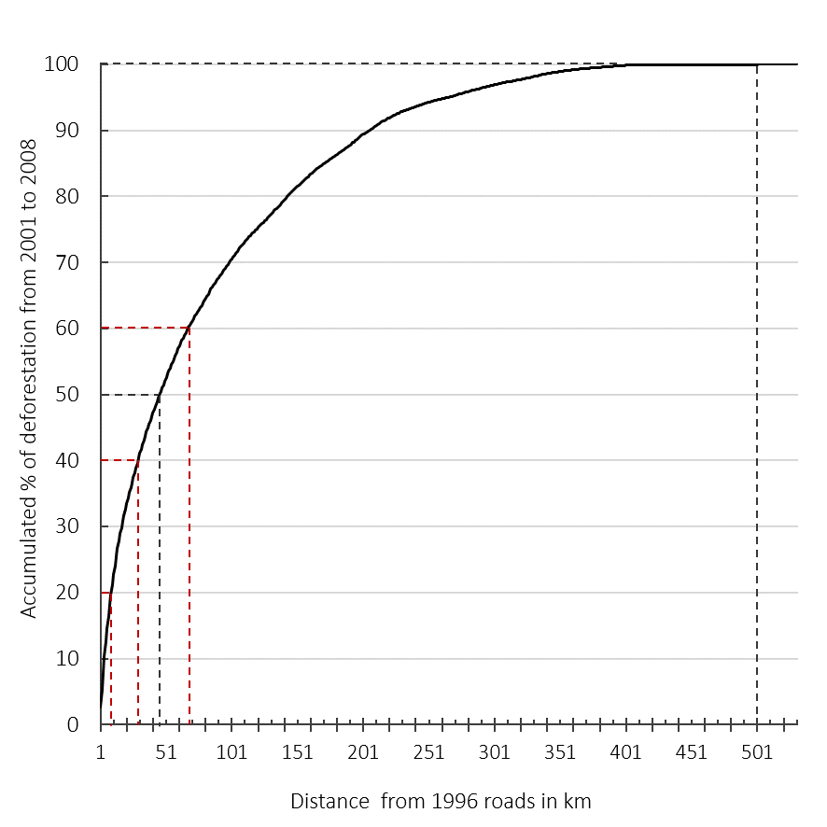

In our first road-distance subset, 50% accumulated deforestation occur until 46km from roads. In our second type of road-distance subsets, 20% accumulated deforestation occur until 10km from roads, points here are highly accessible, then, the accessibility decrease: 20% additional deforestation occur until 30km from roads and 20% additional deforestation occur until 68km from roads. Above that threshold, points are considered to be highly inaccessible.

**Figure 5**

**Pre-Erasure Protection Impacts according to distance to nearest road**

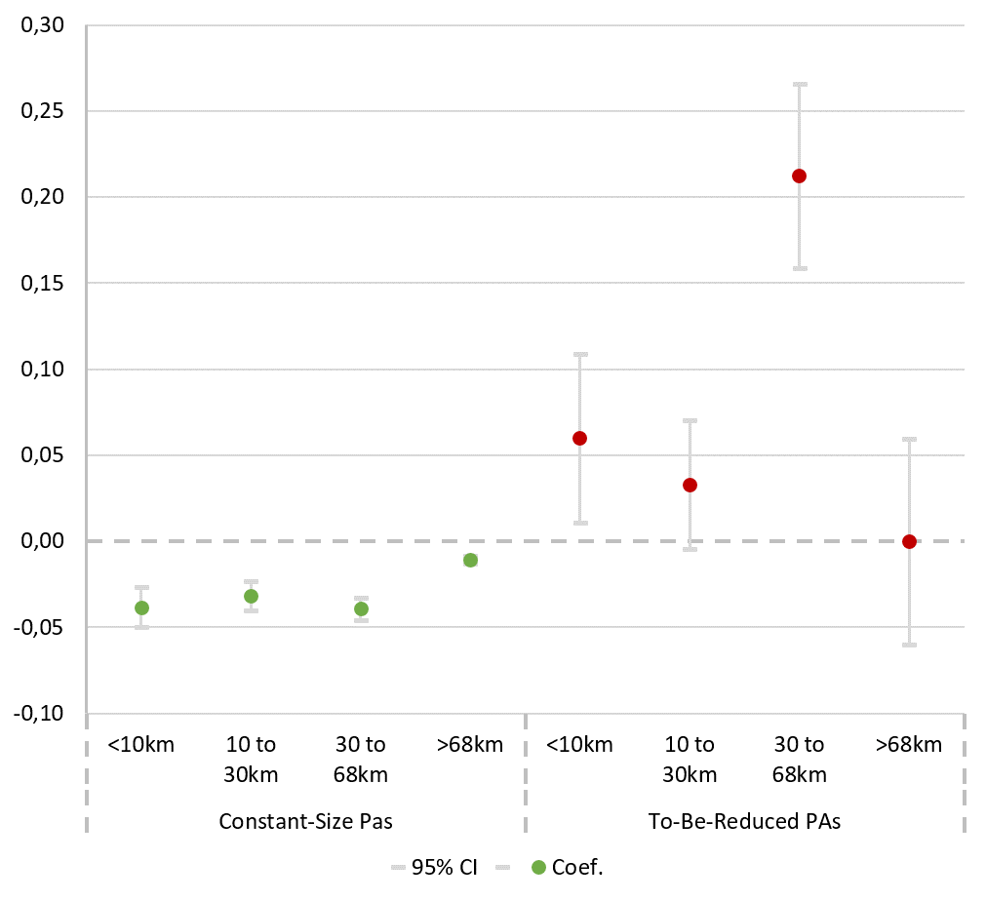

**Table 1 Sources & Descriptions of Covariates**

|  |  |  |  |
| --- | --- | --- | --- |
|  | **Source** | **Step 1** | **Step 2** |
| **Agricultural GDP** | Vector format from the IBGE at the level of the municipality in current prices (1000 real) (IBGE, 2017) | Not used | Average from  2001 to 2008 |
|
|
| **Elevation** | Gridded elevation data from the Shuttle Radar Topography Mission (SRTM) (Jarvis et al., 2008).  90m resolution resampled in 250 by 250 meters. | - | |
| **Slopes** | Gridded elevation data from the Shuttle Radar Topography Mission (SRTM) (Jarvis et al., 2008).  90m resolution resampled in 250 by 250 meters. | Degree from the horizontal (ArcGIS). | |
| **Distance to the nearest river** | Lake, pond and rivers, permanent and navigable. Vector format from the IBGE (IBGE, 2017) | Nearest Distance (km, ArcGis). | |
| **Distance to the nearest road** | Vector format from the Center for International Earth  Science Information Network (CIESIN) (2015) and from  the Brazilian Departamento Nacional de Infraestrutura de Transportes (DNIT, 2017) | Nearest distance from each obs. unit in km with ArcGis in 1996. | Nearest distance from each obs. unit in km with ArcGis In 2006. |
| **Distance to the nearest city** | Vector format from the Environmental Systems Research Institute (ESRI) (ESRI, 2013) | Nearest distance from each obs. unit in km with ArcGis. | |
| **Rainfalls** | Gridded annual data from the version 2.0 of Climate Hazard Group InfraRed Precipitation with Station Data (CHIRPS) (Funk et al., 2015). 0,05 degrees of resolution. | mm. per year in 1995 | Average from  2001 to 2008 in mm. per year |
| **Soil suitability** | Gridded data from the Global Agro-Ecological Zone (FAO and IIASA, 2019) Rainfed soil suitability, high input farming  0.08 degree of resolution | - | |
| **Number**  **Of endemic species** | Vector format from the WWF WildFinder database of species distributions (WWF, 2006; Olson et al., 2001).  High endemism: from 21 to 47 endemic species; medium endemism: from 6 to 20 endemic species; low endemism: from 1 to 5 endemic species; no endemism (0 endemic species) is the baseline. | Not used | 2006 |
| **PA size** | WDPA (IUCN and UNEP-WCMC, 2017)  PADDDtracker (WWF, 2017b) | Not used | - |
| **IUCN category** | WDPA (IUCN and UNEP-WCMC, 2017), PADDDtracker (WWF, 2017b): II: National Parks; V: Protected Landscape; IV: Habi-  tat/Species Management Area; Ia (Strict Nature Reserve)  is the baseline. | Not used | - |

**Table 2 Regressions for Tree-Cover Loss**

|  |  |  |  |  |  |  |
| --- | --- | --- | --- | --- | --- | --- |
| *PROBIT* | **Unprotected Forest Loss 2001-20081** | | | **Protected Forest Loss 2010-20152** | | |
| **Road Distance in 1996** | -0.058 | -0.015 | -0.035 |  |  |  |
| (13.82)*** | (3.37)*** | (8.65)*** |  |  |  |
| **Road Distance in 2006** |  |  |  | -0.737 | -0.270 | -0.094 |
|  |  |  | (23.28)*** | (8.08)*** | (2.79)*** |
| **City Distance** | 0.007 | -0.007 | -0.004 | -0.000 | -0.026 | 0.026 |
| (3.87)*** | (3.15)*** | (1.73)* | (0.04) | (1.87)* | (1.85)* |
| **River Distance** | 0.047 | 0.114 |  | -0.146 | -0.021 |  |
| (8.26)*** | (18.34)*** |  | (3.14)*** | (0.40) |  |
| **Slope** | -0.024 | -0.023 | -0.025 | -0.008 | -0.002 | -0.002 |
| (17.91)*** | (15.81)*** | (17.13)*** | (0.92) | (0.23) | (0.21) |
| **Elevation** | 0.054 | -0.051 | -0.028 | -0.048 | -0.107 | -0.111 |
| (22.64)*** | (16.69)*** | (10.27)*** | (2.19)** | (3.94)*** | (4.37)*** |
| **Land suitable** | -0.035 | 0.017 | 0.027 | -0.116 | 0.037 | 0.037 |
| (5.50)*** | (2.59)*** | (4.02)** | (3.01)*** | (0.90) | (0.91) |
| **Rainfall in 1996** | -0.055 | -0.031 | -0.031 |  |  |  |
| (78.15)*** | (34.15)*** | (34.63)*** |  |  |  |
| **Rainfall 2001-2008** |  |  |  | -0.920 | -0.920 | -0.611 |
|  |  |  | (15.70)*** | (15.70)*** | (8.34)*** |
| **High # of Endemics** |  |  |  | -0.171 | -0.377 | -0.377 |
|  |  |  | (4.54)*** | (7.41)*** | (7.42)*** |
| **Strict IUCN Category** |  |  |  | -0.508 | -0.508 | -0.599 |
|  |  |  | (11.91)*** | (10.91)*** | (12.15)*** |
| **PA Size** |  |  |  | -0.000 | -0.000 | -0.000 |
|  |  |  | (0.57) | (1.21) | (1.23) |
| **Amapa** |  | -0.252 | -0.280 |  | -0.044 | -0.031 |
|  | (7.85)*** | (8.74)*** |  | (0.25) | (0.18) |
| **Amazonas** |  | -0.524 | -0.565 |  | -0.501 | -0.489 |
|  | (28.91)*** | (31.48)*** |  | (5.02)*** | (5.13)*** |
| **Roraima** |  | -0.162 | -0.213 |  | -0.750 | -0.736 |
|  | (7.09)*** | (9.40)*** |  | (3.37)*** | (3.35)*** |
| **Para** |  | 0.428 | 0.376 |  | 0.002 | 0.018 |
|  | (26.55)*** | (23.73)*** |  | (0.01) | (0.19) |
| **Rondonia** |  | 0.655 | 0.613 |  | 0.573 | 0.584 |
|  | (26.55)*** | (35.81)*** |  | (6.80)*** | (7.35)*** |
| **Acre** |  | 0.206 | 0.203 |  | 0.236 | 0.228 |
|  | (9.12)*** | (8.97)*** |  | (2.66)*** | (2.56)** |
| **Mato Grosso** |  | 0.652 | 0.598 |  | 0.083 | -0.019 |
|  | (40.77)*** | (38.09)*** |  | (1.54) | (0.15) |
| **Tocantins** |  | 0.163 | 0.083 |  | 0.609 | 0.627 |
|  | (7.92)*** | (4.14)*** |  | (5.87)*** | (6.72)*** |
| **Maranhao** |  | 0.202 | 0.794 |  | 0.586 | 0.591 |
|  | (10.59)*** | (10.12)*** |  | (2.48)** | (2.52)*** |
| **Constant** | -0.575 | -1.159 | -1.093 | -0.370 | -1.075 | -2.088 |
| (33.19)*** | (35.82)*** | (43.77)*** | (3.01)*** | (6.24)*** | (6.43)*** |
| **Pseudo R2** | 0.05 | 0.11 | 0.11 | 0.11 | 0.16 | 0.16 |
| **Observations** | 772,381 | 772,341 | 772,341 | 150,000 | 149,967 | 149,967 |

1 Looking only at unprotected points, for the controls to compare to 2001-2008 protection.

2 Looking only at protected points, for the controls to compare to 2009-20012 PA erasures.

* p<0.1; ** p<0.05, *** p<0.01

**Table 3A Descriptive Statistics, 1st Time Period: characteristics & 2001-2008 Deforestation**

|  |  |  |  |  |  |  |  |  |  |  |  |  |  |
| --- | --- | --- | --- | --- | --- | --- | --- | --- | --- | --- | --- | --- | --- |
|  | **Unprotected** | | | **Constant-Sized PAs** | | | | | **PAs Reduced In Size 2009-2012** | | | | |
|  | *Mean* | *Min.* | *Max.* | *Mean* | *DiM\** | *Combined KS\** | *Min.* | *Max.* | *Mean* | *DiM\*\** | *Combined KS\*\** | *Min.* | *Max.* |
| **Road Distance** | 102 | 0 | 530 | 151 | 0.0 | 0.0 | 0 | 523 | 38 | 0.0 | 0.0 | 0 | 129 |
| **City Distance** | 408 | 2 | 1108 | 359 | 0.0 | 0.0 | 5 | 926 | 302 | 0.0 | 0.0 | 27 | 585 |
| **River Distance** | 55 | 0 | 297 | 54 | 0.0 | 0.0 | 0 | 265 | 51 | 0.0 | 0.0 | 0 | 112 |
| **Slope** | 1.6 | 0 | 41 | 1.9 | 0.0 | 0.0 | 0 | 49 | 1.4 | 0.0 | 0.0 | 0 | 18 |
| **Elevation** | 200 | 0 | 1597 | 164 | 0.0 | 0.0 | 0 | 2410 | 196 | 0.06 | 0.0 | 25 | 498 |
| **Land Suitable** | 81% | 0 | 1 | 82% | 0.39 | 0.15 | 0 | 1 | 88% | 0.0 | 0.0 | 0 | 1 |
| **Rainfall** | 2199 | 821 | 4598 | 2369 | 0.0 | 0.0 | 1053 | 3892 | 1870 | 0.0 | 0.0 | 1493 | 2680 |
| **Forest Loss 2001-2008** | 2.7% | 0 | 1 | 0.4% | 0.0 | 0.0 | 0 | 1 | 8% | 0.0 | 0.0 | 0 | 1 |

*P-values for differences in means and differences in distributions between Unprotected and Constant-sized.

**P-value for differences in means and differences in distributions between Unprotected and Reduced in Size.

**Table 3B Descriptive Statistics, 2nd Time Period: characteristics & 2009-2012 Deforestation**

|  |  |  |  |  |  |  |  |  |
| --- | --- | --- | --- | --- | --- | --- | --- | --- |
|  | **Constant-Sized PAs** | | | **PAs Reduced In Size 2009-2012** | | | | |
|  | *Mean* | *Min.* | *Max.* | *Mean* | *p\** | *Combined KS\*\** | *Min.* | *Max.* | |
| **Road Distance** | 103 | 0 | 421 | 30 | 0.0 | 0.0 | .02 | 96 | |
| **City Distance** | 354 | 5 | 926 | 304 | 0.0 | 0.0 | 27 | 585 | |
| **River Distance** | 47 | 0 | 302 | 49 | 0.0 | 0.0 | 0 | 112 | |
| **Slope** | 1.9 | 0 | 49 | 1.4 | 0.4 | 0.0 | 0 | 18 | |
| **Elevation** | 175 | 0 | 2410 | 192 | 0.0 | 0.0 | 25 | 498 | |
| **Land Suitable** | 75% | 0 | 1 | 87% | 0.0 | 0.0 | 0 | 1 | |
| **Rainfall** | 204 | 85 | 352 | 154 | 0.0 | 0.0 | 115 | 226 | |
| **Forest Loss 2010-2015** | 0.3% | 0 | 1 | 5% | 0.0 | 0.0 | 0 | 1 | |
| **High Endemic** | 27% | 0 | 1 | 62% | 0.0 | 0.0 | 0 | 1 | |
| **Strict IUCN** | 37% | 0 | 1 | 53% | 0.0 | 0.0 | 0 | 1 | |
| **PA Size** | 16931 | 0.5 | 46428 | 6629 | 0.0 | 0.0 | 0.1 | 26647 | |

*P-values for differences in means and differences in distributions between Unprotected and constant-size.

**P-value for differences in means and differences in distributions between Unprotected and Reduced in Size **Table 4A**

**Improving Covariate Balances for PAs’ Impacts on 2001-2008 Deforestation**

|  |  |  |  |  |  |  |  |
| --- | --- | --- | --- | --- | --- | --- | --- |
|  | **Unmatched** | **Mahalanobis Distance Matching** | | | **Propensity Score Matching** | | |
| % bias | DiM* | % bias** | % reduced*** | DiM | % bias | % reduced |
|
|
| **PAs Erased During 2009-2012** *versus* **Never Protected** | | | | | | | |
| Land suitability | 17.2 | 1.00 | 0.0 | 100.0 | 0.86 | 0.4 | 97.4 |
| Distance to the nearest city | -56.2 | 0.55 | -1.5 | 97.4 | 0.02 | 5.2 | 90.7 |
| Distance to the nearest road | -79 | 0.13 | -1.9 | 97.6 | 0.00 | 6.8 | 91.4 |
| Distance to the nearest river | -12.8 | 0.96 | -0.1 | 99.2 | 0.02 | -6.3 | 50.2 |
| Slope | -9.2 | 0.93 | 0.2 | 97.9 | 0.46 | -1.8 | 79.8 |
| Elevation | -7.8 | 0.90 | 0.2 | 97.0 | 0.42 | -2.1 | 72.3 |
| Rainfall | -50.7 | 0.08 | -2.6 | 96.5 | 0.00 | -11.2 | 85.0 |
| **Always Protected Through 2015** *versus* **Never Protected** | | | | | | | |
| Land suitability | 1.8 | 1.00 | 0.0 | 100.0 | 0.31 | -0.6 | 68.0 |
| Distance to the nearest city | -24.9 | 0.32 | -0.6 | 97.8 | 0.00 | -8.8 | 64.8 |
| Distance to the nearest road | 40.1 | 0.36 | 0.6 | 98.5 | 0.00 | -7.2 | 82.0 |
| Distance to the nearest river | -4.0 | 0.01 | 1.5 | 62.7 | 0.00 | -5.5 | -36.8 |
| Slope | 10.6 | 0.24 | 0.5 | 95.1 | 0.00 | -1.8 | 82.6 |
| Elevation | -24.9 | 0.03 | 1.0 | 95.8 | 0.00 | -2.3 | 90.8 |
| Rainfall | 16.9 | 0.35 | -0.5 | 97.4 | 0.27 | 0.6 | 96.9 |

*P-value of simple difference in mean between treated and untreated matched samples.

* Standardized bias is the difference between the treated and matched untreated covariate means, as a % of the square root of the average of treated and matched untreated sample variances (Rosenbaum and Rubin, 1985).

***The reduction in standardized bias is the difference between the standardized bias before and after matching.

**Table 4B**

**Improving Covariate Balances for PA size reductions Impacts on 2010-2015 Deforestation**

|  |  |  |  |  |  |  |  |
| --- | --- | --- | --- | --- | --- | --- | --- |
|  | **Unmatched** | **Mahalanobis Distance Matching** | | | **Propensity Score Matching** | | |
| % bias | DiM* | % bias** | % reduced*** | DiM | % bias | % reduced |
|
|
| **Erased in 2009/2012 vs****Constant-Size** | | | | | | | |
| Land suitability | 30.9 | 1.00 | 0.0 | 100 | 0.61 | 1.3 | 95.8 |
| Distance to the nearest city | -30.6 | 0.08 | 5.9 | 80.7 | 0.85 | 0.5 | 98.2 |
| Distance to the nearest road | -118.9 | 0.02 | 2.9 | 97.6 | 0.01 | -3.7 | 96.9 |
| Distance to the nearest river | 6.3 | 0.01 | 6.2 | 4.3 | 0.26 | 2.7 | 56.8 |
| Slope | -21.5 | 0.29 | 1.9 | 91.2 | 0.16 | -3.6 | 83.2 |
| Elevation | 13.9 | 0.29 | 2.2 | 84.6 | 0.00 | -11.4 | 18.8 |
| Rainfall | -128.4 | 0.43 | 2.7 | 97.9 | 0.00 | 8.6 | 93.3 |
| PA size | -85.8 | 0.52 | -1.9 | 97.8 | 0.98 | -0.1 | 99.9 |
| Endemic species | 76.6 | 1.00 | 0.0 | 100 | 0.89 | -0.3 | 99.6 |
| IUCN category | 33.1 | 1.00 | 0.0 | 100 | 0.12 | -4.8 | 85.3 |

**Table 5A 2001-2008 Impacts of PAs Constant-sized Through 2015**

|  |  |  |  |  |  |  |  |  |  |  |  |  |  |
| --- | --- | --- | --- | --- | --- | --- | --- | --- | --- | --- | --- | --- | --- |
|  | **All** | **<48**  **km** | **>48**  **km** | **<10**  **km** | **10-30**  **km** | **30-68 km** | **>68**  **km** | **In**  **Arc** | **Not**  **Arc** | **RO** | **PA** | **AM** | |
| Total | 643,198 | 258,722 | 384,423 | 98,812 | 103,653 | 120,345 | 320,354 | 181,192 | 266 ,160 | 29,845 | 151,347 | 236,397 | |
| Treated | 62,480 | 19,153 | 43,316 | 6,500 | 8,272 | 10,094 | 37,614 | 16,65 | 33,237 | 5,923 | 10,725 | 28,776 | |
| **One to One Mahalanobis Distance Matching, caliper (0.5)** | | | | | | | | | | | | | | |
| ATT1 | -.02*** | -.03*** | -.01*** | -.04*** | -.03*** | -.04*** | -0.01*** | -0.7*** | -.003*** | -.09*** | -.05*** | -.00 | |
| (.001) | (.003) | (.001) | (.006) | (.004) | (.004) | (.001) | (.004) | (.001) | (.008) | (.004) | (.001) | |
| Bias2 | 0.7 | 0.6 | 0.9 | 0.6 | 0.8 | 0.5 | 1.0 | 1.1 | 0.9 | 1.3 | 1.2 | 1.1 | |
| **One to Two Mahalanobis Distance Matching, caliper (0.25)** | | | | | | | | | | | | | | |
| ATT | -.02*** | -.03*** | -.01*** | -.04*** | -.03*** | -.03*** | -0.01*** | -.07*** | -.00*** | -.08*** | -.05*** | -.001 | |
| (.001) | (.002) | (.001) | (.005) | (.003) | (.003) | (.001) | (.003) | (.001) | (.007) | (.004) | (.001) | |
| Bias | 1.4 | 1.4 | 1.6 | 1.4 | 1.6 | 1.7 | 1.7 | 2.2 | 1.3 | 2.3 | 2.4 | 1.3 | |
| **One to One Propensity Score Matching, caliper (0.01), without replacement** | | | | | | | | | | | | | | |
| ATT | -.04*** | -.05*** | -.03*** | .06*** | -.06*** | -.05*** | -.03*** | -.09*** | -.00*** | -.12*** | -.07*** | -.003*** | |
| (.0009) | (.002) | (.001) | (.003) | (.003) | (.002) | (.001) | (.002) | (.005) | (.004) | (-.002) | (.001) | |
| Bias | 4.2 | 1.2 | 3.5 | 2.9 | 1.6 | 2.1 | 3.6 | 3.7 | 1.3 | 1.8 | 2.8 | 2.4 | |
| **Sensitivity Analysis** | | | | | | | | | | | | | |
| Gamma3 | 5.8 | 3.8 | 10 | 3.1 | 4.2 | 6.9 | 10 | 10 | 2.3 | 10 | 10 | 1.8 |
| P_mh- | 0.04 | 0.03 | 0.02 | 0.03 | 0.04 | 0.04 | 0.01 | 0.00 | 0.03 | 0.00 | 0.00 | 0.03 |

* p<0.1; ** p<0.05; *** p<0.01

1Average Treatment effect on the Treated. Standard errors are in parentheses.

2Absolute value of the difference of means in the treated and matched untreated subsamples as a percentage of the square root of the average sample variance in both groups. Here, we report the average for all covariates.

3Critical value of the Rosebaum’s *τ*. It indicates by how much unobserved confounding factors could negatively influence selection into treatment. P_mh- is the associated significance level.

**Table 5B 2001-2008 Impacts of PA Size Reductions during 2009-2012**

|  |  |  |  |  |  |  |  |  |  |  |  |  |  |  |  |  |  |  |  |  |  |  |  |  |  |  |  |  |  |
| --- | --- | --- | --- | --- | --- | --- | --- | --- | --- | --- | --- | --- | --- | --- | --- | --- | --- | --- | --- | --- | --- | --- | --- | --- | --- | --- | --- | --- | --- |
|  | | | **All** | | **<48**  **km** | | **>48**  **km** | | **<10**  **km** | | **10-30**  **km** | | **30-68**  **km** | | **>68**  **km** | | **In**  **Arc** | | | **Not**  **Arc** | | **RO** | | | **PA** | | |  | **AM** |
| Total | | | 583,184 | | 241,334 | | 341,852 | | 92,346 | | 96,248 | | 110,738 | | 283,278 | | 166,597 | | | 233,374 | | 25,807 | | | 91,027 | | |  | 205,257 |
| Treated | | | 2,463 | | 1,765 | | 703 | | 576 | | 867 | | 487 | | 538 | | 2,062 | | | 406 | | 1,894 | | | 168 | | |  | 18 |
|  | **One to One Mahalanobis Distance Matching, common support, caliper (0.5)** | | | | | | | | | | | | | | | | | | | | | | | | | | | | | |
| ATT1 | | | .06*** | | .06*** | | .06*** | | .06*** | | .03* | | .21*** | | 0 | | .05** | | .00 | | .05*** | | -.02 | | |  | .05 | | |
| (.014) | | (.014) | | (.024) | | (.025) | | (.019) | | (.027) | | (.030) | | (.021) | | (.003) | | (.019) | | (.036) | | |  | (.078) | | |
| Bias2 | | | 0.9 | | 0.3 | | 2.1 | | 1.0 | | 0.6 | | 2.0 | | 2.1 | | 1.1 | | 2.9 | | 0.6 | | 1.7 | | |  | 4.0 | | |
|  | **One to Two Mahalanobis Distance Matching, common support, caliper (0.25)** | | | | | | | | | | | | | | | | | | | | | | | | | | | | | |
| ATT | | | .06*** | | .07*** | | .08*** | | .05** | | .03* | | .22*** | | .002 | | .05*** | | 0 | | .05*** | | -.04 | | |  | 0 | | |
| (.013) | | (.13) | | (.02) | | (.022) | | (.017) | | (.025) | | (.021) | | (.018) | | (.004) | | (.017) | | (.020) | | |  | (.081) | | |
| Bias | | | 1.2 | | 0.7 | | 2.4 | | 1.8 | | 0.8 | | 2.4 | | 2.7 | | 1.1 | | 2.1 | | 1.7 | | 1.9 | | |  | 4.3 | | |
|  | **One to One Propensity Score Matching, common support, caliper (0.01), without replacement** | | | | | | | | | | | | | | | | | | | | | | | | | | | | | |
| ATT | | | .11*** | | .12*** | | .11*** | | .13*** | | .11*** | | .22*** | | .07*** | | .10*** | | .04*** | | .09*** | | -.08*** | | |  | .15*** | | |
| (.009) | | (.010) | | (.014) | | (.019) | | (.015) | | (.024) | | (.012) | | (.011) | | (.009) | | (-.012) | | (.029) | | |  | (.077) | | |
| Bias | | | 4.8 | | 2.8 | | 5.8 | | 5.1 | | 4.8 | | 1.6 | | 3.8 | | 1.6 | | 7.8 | | 5.5 | | 4.6 | | |  | 10 | | |
| **Sensitivity Analysis** | | | | | | | | | | | | | | | | | | | | | | | | | | | | | |
| Gamma3 | | 2.4 | | 2.5 | | 2.6 | | 2.4 | | 2.4 | | 3.4 | | 2.2 | | 1.8 | | 2.4 | | | 1.5 | | | 1.4 | | | 1 | | |
| P_mh+ | | 0.02 | | 0.02 | | 0.049 | | 0.04 | | 0.04 | | 0.04 | | 0.049 | | 0.04 | | 0.04 | | | 0.02 | | | 0.04 | | | 0.23 | | |

* p<0.1; ** p<0.05; *** p<0.01

1Average Treatment effect on the Treated. Standard errors are in parentheses.

2Absolute value of the difference of means in the treated and matched untreated subsamples as a percentage of the square root of the average sample variance in both groups. Here, we report the average for all covariates.

3Critical value of the Rosebaum’s *τ*. It indicates by how much unobserved confounding factors could negatively influence selection into treatment. P_mh+ is the associated significance level.

**Table 6**

**2010-2015 Post-Reduction Deforestation Impacts of 2009-2012 PA Size Reductions**

|  |  |  |  |  |  |  |  |  |  |  |  |  |  |  |  |  |  |  |  |  |  |  |  |  |  |  |  |  |  |
| --- | --- | --- | --- | --- | --- | --- | --- | --- | --- | --- | --- | --- | --- | --- | --- | --- | --- | --- | --- | --- | --- | --- | --- | --- | --- | --- | --- | --- | --- |
|  | | | **All** | | **<48**  **km** | | **>48**  **km** | | **<10**  **km** | | **10-30**  **km** | | **30-68**  **km** | | **>68**  **km** | | **In**  **Arc** | | | **Not**  **Arc** | | **RO** | | | **PA** | | |  | **AM** |
| Total | | | 150,024 | | 44,453 | | 105,571 | | 11,688 | | 19,560 | | 30,120 | | 88,656 | | 62,881 | | | 68,089 | | 9,239 | | | 30,427 | | |  | 63,244 |
| Treated | | | 2,245 | | 1,605 | | 640 | | 534 | | 784 | | 408 | | 519 | | 1,768 | | | 473 | | 1,565 | | | 203 | | |  | 85 |
|  | **One to One Mahalanobis Distance Matching, common support, caliper (0.5)** | | | | | | | | | | | | | | | | | | | | | | | | | | | | | |
| ATT1 | | | .03*** | | .04*** | | .001 | | .02* | | .04*** | | .05*** | | -.00 | | .03*** | | 0 | | .03*** | | .006 | | |  | 0 | | |
| (.005) | | (.006) | | (.008) | | (.012) | | (.010) | | (.016) | | (.00) | | (.007) | | (0) | | (.009) | | (.011) | | |  | (0) | | |
| Bias2 | | | 2.4 | | 1.8 | | 5.6 | | 1.4 | | 1.6 | | 3.7 | | 5.6 | | 1.9 | | 7.3 | | 1.0 | | 1.8 | | |  | 2.3 | | |
|  | **One to Two Mahalanobis Distance Matching, common support, caliper (0.25)** | | | | | | | | | | | | | | | | | | | | | | | | | | | | | |
| ATT | | | .02*** | | .03*** | | 0 | | .03** | | .04*** | | .01 | | -.00 | | .03*** | | 0 | | .03*** | | -.00 | | |  | 0 | | |
| (.005) | | (.006) | | (.008) | | (.014) | | (.010) | | (.009) | | (.005) | | (.007) | | (0) | | (.009) | | (.009) | | |  | (0) | | |
| Bias | | | 1.8 | | 1.2 | | 5.9 | | 1.7 | | 0.9 | | 3.9 | | 6 | | 1.2 | | 6.0 | | 1.5 | | 1.7 | | |  | 2.4 | | |
|  | **One to One Propensity Score Matching, common support, caliper (0.01), without replacement** | | | | | | | | | | | | | | | | | | | | | | | | | | | | | |
| ATT | | | .05*** | | .06*** | | .04*** | | .03*** | | .05*** | | .15*** | | -.00 | | .07*** | | .02** | | .09*** | | 0 | | |  | 0 | | |
| (.005) | | (.007) | | (.007) | | (.011) | | (.008) | | (.018) | | (.003) | | (.007) | | (.006) | | (.008) | | (.013) | | |  | (0) | | |
| Bias | | | 3.8 | | 4.2 | | 6.5 | | 6.7 | | 5.9 | | 5.0 | | 7.4 | | 3.0 | | 26.2 | | 4.1 | | 5.2 | | |  | 29.6 | | |
| **Sensitivity Analysis** | | | | | | | | | | | | | | | | | | | | | | | | | | | | | |
| Gamma3 | | 6.4 | | 5.4 | | 3.7 | | 1.2 | | 5 | | 10 | | 1 | | 8 | | 1 | | | 9.4 | | | 1 | | | 1 | | |
| P_mh+ | | 0.049 | | 0.049 | | 0.049 | | 0.03 | | 0.05 | | 0.03 | | 0.049 | | 0.049 | | 0.12 | | | 0.049 | | | 0.70 | | | . | | |

* p<0.1; ** p<0.05; *** p<0.01

1Average Treatment effect on the Treated. Standard errors are in parentheses.

2Absolute value of the difference of means in the treated and matched untreated subsamples as a percentage of the square root of the average sample variance in both groups. Here, we report the average for all covariates.

3Critical value of the Rosebaum’s *τ*. It indicates by how much unobserved confounding factors could negatively influence selection into treatment. P_mh+ is the associated significance level.

1. This threshold corresponds to the definition of tropical forest within the United Nations Framework Convention on Climate Change (UNFCCC): any area of at least 0.5 ha with 10 to 30% tree cover density (Chazdon et al., 2016). This is also the official definition of tropical forest used in the CBD (Convention on Biological Diversity, 2019).
2. We matched with different parameters − e.g., 1 to 3 neighbors − dropping observations for which matches were not found for calipers of 0.10, 0.25 and 0.5 standard deviations of the covariates. We report the number of matched observations and mean standardized bias. We tried to maximize common support and minimize standardized bias.
3. Results are available upon request.
4. Regions are defined as Outside the ‘arc of deforestation’ (Amazonas, Roraima, Amapá), which has low economic pressure versus In the arc of deforestation (namely Rondônia and Pará), where economic pressure are much higher. While there are other Amazonian states both inside and outside the arc, they have not featured in size reductions.
5. Road networks evolve. For 2009-2012 erasures, we use 2006 roads (DNIT, 2017) that differ little from 1996 since these are formal roads (surely the informal roads do keep rising). The threshold obtained is approximately the same.